Combining Services and PermissionsTheory (1 hour):Integrating permissions with web hosting for secure access.Practical (1 hour):Secure access to a hosted site using permissions.Task: Test and document restricted access to web resources.

Tasks

1. Create a new directory called mysite in your home folder, place an index.html file inside it, and set permissions so only your user can read and access the site files.

ANS:

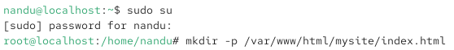

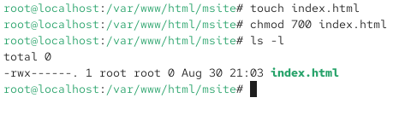

2. Configure your Apache or Nginx server to serve the mysite directory as a website, then test if you can access it from your browser while logged in as your user.

ANS:

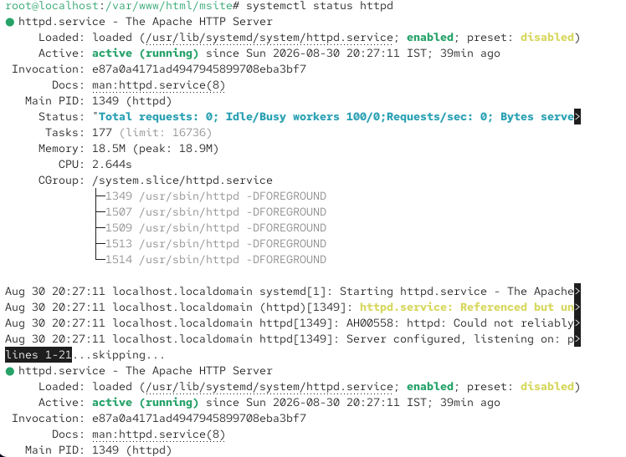



3. Change the permissions of the mysite directory so that another user on the system cannot access the site files directly. Try to access the files as the other user and note the result.<br><br><em><strong>Hint:</strong> Use chmod and su or a different terminal window for the second user.

ANS:

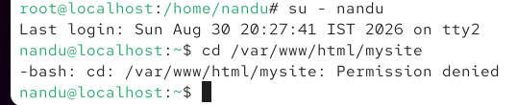



4. Document the steps you took to restrict access to your hosted site, including the commands used, permission settings, and screenshots or outputs showing successful and failed access attempts.

ANS:

I restricted access to my hosted website so that only the owner could access the website files.
I first found the location of my mysite directory using the following command:



Step 2: I changed the permissions so only the owner could access the website files:



Step 3: Start the Server and chek file



Step 4: change permission and user and then chek file





